**DAILY ONLINE ACTIVITIES SUMMARY**

|  |  |  |  |  |  |  |  |
| --- | --- | --- | --- | --- | --- | --- | --- |
| **Date:** | **22/05/2020** | | | | **Name:** | **JYOTHI LAKSHMI** | |
| **Sem & Sec** | **8th sem, B sec** | | | | **USN:** | **4AL16CS129** | |
| **Online Test Summary** | | | | | | | |
| **Subject** | | **BDA-IA2** | | | | | |
| **Max. Marks** | | **40** | | **Score** | | **25** | |
| **Certification Course Summary** | | | | | | | |
| **Course** | **JAVA PROGRAMMING(240 mins)** | | | | | | |
| **Certificate Provider** | | | **Great Learning** | **Duration** | | | **30 mins** |
| **Coding Challenges** | | | | | | | |
| **Problem Statement: 1) To Find the number that is missing from the array containing ‘n’ distinct number taken from 0,1,2….n** | | | | | | | |
| **Status: Completed** | | | | | | | |
| **Uploaded the report in Github** | | | | **Yes** | | | |
| **If yes Repository name** | | | |  | | | |
| **Uploaded the report in slack** | | | | **Yes** | | | |

Online Test Details:

Online examination is conducting a test online to measure the knowledge of the participants on a given topic. With online examination students can do the exam online. The test was on the subject System Modeling and Simulation under the topic Random numbers generation technique.

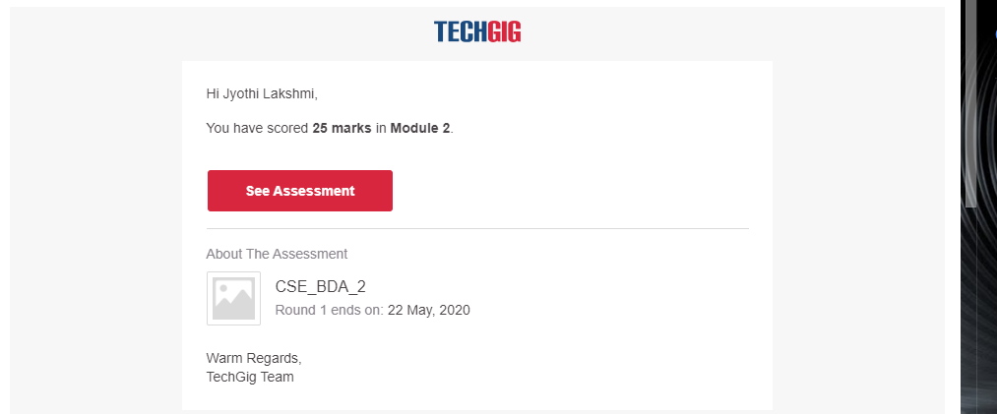

ONLINE CERTIFICATION COURSE:

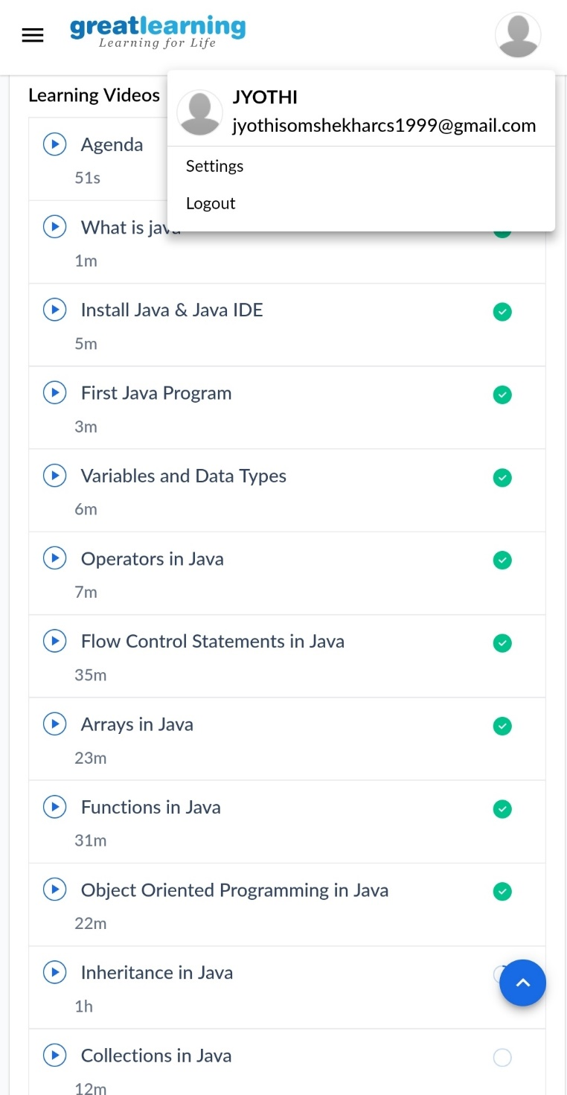

Coding Challenges Details:

1. Find the number that is missing from the array containing ‘n’ distinct number taken from 0,1,2,…..n

#include<stdio.h>

Int getMissingNo(int a[],int n)

{

Int i,total;

total= (n+1)*(n+2)/2;

for(i=0;i<n;i++)

{

total-=a[i];

}

}

int main()

{

int a[]={1,2,3,4,5,6};

int miss= getMissingNo(a,5);

printf(“%d”,miss);

getchar();

}

Output: 3